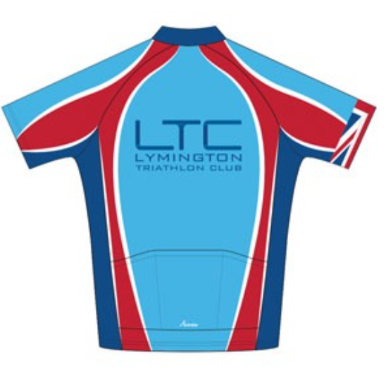
Risk Assessment (General) for Forest Runs

Risk assessments are concerned with identifying the hazards (i.e. things which might go wrong or cause an accident/injury), evaluating the likelihood of a particular event occurring (i.e. level of risk) and putting measures in place needed to reduce or eliminate the risk.

Event type | Forest runs
Dates of events | Weekly, throughout the year
Venue | New Forest | Organising Club | Lymington Triathlon Club
Name of person in charge | Run Leader | Position | Event Organiser
Name of person completing this form | Robert Norley | Position | LTC Member
Signature |  | Risk assessment dated | 28/1/2020
Risk assessment checked by | Moz Malpiedi, Ron Wilson, Neil Carden | Position | LTC Members
Signature |  | Date | 28/1/2020

The Risk Assessment

It is essential that the mitigation column is completed in detail so that the control measures and who is responsible is fully understood in advance of the activity.

NB: The Run Leader is responsible for planning the intended route, and avoiding significant hazards where practicable. The Run Leader must also make a dynamic risk assessment of the conditions found on the course on the day, and instigate mitigations where deemed necessary. Participants must follow the direction of the Run Leader, and any deputy.

Phase | Hazard | Level of Risk | Action - based on guidance from British Triathlon
Pre-RUN | Covid-19 | Medium  The UK has lowered its Covid-19 alert level from 4 to 3, meaning transmission of the virus is no longer judged to be “high or exponentially rising”, | - No groups greater than 6 people  - Run side by side or maintain a minimum spacing of 2-5m between runners due to potential transmission by aerosols  - Log of attendees (or photo) to facilitate contact tracing  - If you feel unwell after attending a session please contact the club to facilitate contact tracing  - Regular use of hand sanitiser before/after contact with people or equipment – everyone to bring their own bottle  - Individual athletes to carry out a self-assessment before attending session – do NOT attend if feeling unwell or have been in contact with someone who has been potentially infected

Throughout the risk assessment, the following have been used as guidelines for ‘likelihood’
HIGH = might reasonably expect this to happen to at least one person during the event
MEDIUM = might reasonably expect this to happen at least once during a season
LOW = might reasonably expect never to see this even in many years of such events
NONE = not applicable because the risk does not exist. Included as confirmation that the risk has been assessed.

Hazard | Possible outcome / injury |  | Mitigation
 | Notes on potential severity | Likelihood | What control measure? |  | Responsibility for control measures
In course area
- Uneven surfaces  - Slippery surfaces  - Tree roots/branches | Tripping / slipping – minor injury | MEDIUM | Course appropriate to those taking part. |  | Run Leader
 |  |  | Suitable footwear to be worn by participants. |  | Participant
- Slopes/steps | Falls – minor, or possibly major, injury | MEDIUM | Course appropriate to those taking part. |  | Run Leader
 |  |  | Course hazards to be pointed out en route |  | Participant/Run Leader
- Vegetation (prickly, stinging) | Scratches or stings – trivial injury | MEDIUM | Suitable leg and torso cover to be worn. |  | Participant
- Wire / ruined fences | Scratches – minor injury | LOW | Fence climbing to be avoided |  | Participant/Run Leader
- Litter (glass, used needles) | Glass cut – minor injury  Needle-borne infection – major injury | NONE |  |  | N/A
- Water (water courses, marshes, ponds) | Drowning – serious injury or death | LOW | Identified by run planner in advance, or dynamically on run. Routes planned to avoid them |  | Run Leader
- High walls, unguarded steep edges | Falling – serious injury or death | LOW | Identified by run planner in advance, or dynamically on run. Routes planned to avoid them |  | Run Leader
- Traffic (including road crossings) | Collision between runner and vehicle – serious injury or death | LOW | Road crossing to be avoided where practicable. Where road needs to be crossed, group to cross as a whole, when safe to do so. | Group/Run Leader
- Railway lines | Collision between runner and train – serious injury or death  Contact with electrified lines - serious injury or death | LOW | Identified by run planner in advance, or dynamically on run. Planned routes will avoid busy lines such such as the Southampton/Bournemouth line and use rail bridges and under-passes.  Only designated crossing points on the Lymington/Brockhurst line will be used (clear line of sight/good signage/ good gates) – with care! |  | Participant
- Mineshafts / caves | Falling – serious injury or death | NONE | None in area of courses |  | N/A
- Military debris | Trips, cuts, scratches – minor injury  Explosion – serious injury or death | LOW | None identified in area of courses |  | N/A
- Wildlife & livestock | Kicks / bites from wild / roaming animals & livestock if disturbed / frightened | LOW | Group to give animals given a wide berth. Participants used to running in the New forest and aware. |  | Participant
* Tick bites | Potential of contracting Lyme Disease, and other tick-borne diseases - mild to serious chronic illness | MEDIUM | Leg check at end of run. Consider wearing running longs in times of high tick activity. Participant to seek medical advice immediately on developing a rash from a tick bite. |  | Participant
- Power lines | No HV cables in area of courses. | NONE | None in area of courses |  | N/A
Participant
- Clothing / shoes | Poor temperature control – see ‘Heat’ and ‘Cold’  Slipping or twisting ankle – minor injury | LOW | Clothing suitable for walking/running in woods and open moorland. |  | Particpant
- Existing medical conditions  - Unexpected reactions/allergies | Sudden serious illness or death | LOW | Participant to decide whether they are fit enough for proposed run. Participant to alert Run Leader of any underlying serious health concern pertinent to run. |  | Participant/Run Leader
- Lost particpant | Unable to locate self or find way back to finish. | LOW | Run Leader to ensure that participants run as a group, that the pace is appropriate and that group waits for any straggler. Run Leader to designate experienced buddy for any participant struggling. |  | Group/Run Leader
- Disorientation (inc caused by tiredness) | Longer exposure to heat/cold than planned for – usually minor (see ‘Heat’ and ‘Cold’ for major considerations)  Lost – stumble across hazard away from courses resulting in injury - usually minor (see individual hazards for major considerations)  Lost – unable to find way back | LOW  LOW  LOW | Courses appropriate to those taking part. Course route pre-planned or tailored dynamically to suit group. |  | Run Leader/Group
 |  |  | Group running to reduce likelihood of individuals straying off-course |  | Group/Run Leader
Other people/activities in area
- General public  - Cyclists  - Horse riders | Runner collides with walker  Collision with cyclist – minor injury  Collision with horse – minor injury | LOW  LOW  LOW | Participants advised to take care. |  | Participant/Run Leader
- Walking dogs | Attacked by uncontrolled dog – major injury | LOW | Participants advised to take care. |  | Participant/Run Leader
- Forest maintenance | Machinery/ Falling tree/Log piles – major injury | LOW | Areas being worked signed by Forestry Commission. Run Leader ensures courses planned to avoid. |  | Run Leader
- Shooting / archery | Accidental shooting – serious injury or death | NONE | None permitted in area of courses |  | N/A
- Stranger danger | Vulnerable person injured by stranger | LOW | Under-18’s to be chaperoned by responsible adult. Group running to avoid lone participants. |  | Group/Run Leader
Weather
- Heat / sun | Heatstroke – serious injury or death | LOW | Course duration limited to 90 minutes. Courses in mixed forest (shaded) and heathland. Appropriate running clothing to be worn by participant. |  | Participant/Run Leader
- Cold / rain / snow / hail / ice | Hypothermia – serious injury or death  Slippery surfaces – major injury | LOW  MEDIUM | Participant to wear appropriate clothing & footwear Plan for event cancellation if necessary, dependent on weather conditions.  Curtail course if necessary.  Consider making cagoules compulsory if weather very poor. |  | Participant/Run Leader
- High winds  - Lightning | Wind blown items / falling branches – major injury  Lightning strike – major injury | MEDIUM | Choose course appropriate for weather. Curtail course if necessary. Plan for event cancellation if necessary. |  | Run Leader

