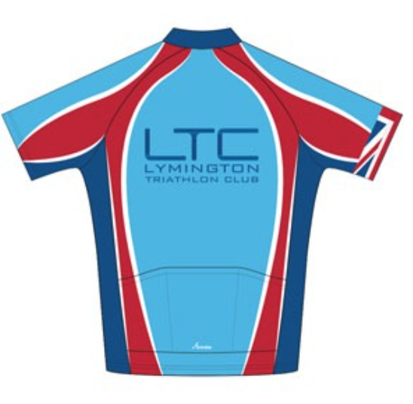
Generic Risk Assessment for Club Coached Pool Swimming Sessions – Created December 2019
LTC Risk Assessment Introduction.
A Risk Assessment is an important step in protecting both our members and our Club as a whole. Every time we swim, we are exposing ourselves to various risks and the Risk Assessment helps us to focus our minds on these risks and hopefully help to reduce them. As previously stated, the club is required to have in place a Risk Assessment in order to manage and hopefully reduce or even eliminate the risks. It is not expected that the club eliminates all risk, but we are required to protect people as far as is ‘reasonably practicable’.

What is Risk Assessment?
HAZARD = something with the potential to cause harm RISK = the chance, great or small, of coming into contact with that hazard. This Risk Assessment is an examination of what, in our sport, presents a hazard and could cause harm to people. Once a hazard has been identified it is then a matter of assessing what the risk is in relation to that hazard. A grid system is then used to combine the two and give a graded level of risk LOW, MEDIUM, HIGH. When that has been done the next stage is to think of ways to reduce / eliminate that risk. These are the control measures. Once the control measures have been implemented you are then left with the residual risk (or the risk could have been completely eliminated). The Risk Assessment can then be reviewed on a regular basis to assess a number of things e.g. are the existing control measures working, have any new hazards been identified, have any existing hazards been eliminated.

Duty of Care
The LTC committee and Swimming Captain have taken the responsibility of preparing this Risk Assessment and making it accessible to all. Individual Members of the club have a duty of care not only to themselves but to members of the public and to the persons with whom they are swimming. i.e. The duty of care requires you to consider the consequences of your acts and omissions and to ensure that those acts and/or omissions do not give rise to a foreseeable risk of injury to any other person.
LTC pool coached pool sessions cater for a wide range of abilities and require individual participants to self-assess their ability to take part. It is strongly recommended that swimmers inform the Coach of their prior swimming history and potentially be able to swim 200 metres comfortably.
All swimmers are reminded that they are responsible for their own safety, individuals take part in any group activities at their own risk. We strongly urge all swimmers to obtain appropriate 3rd party insurance as a minimum. It should be noted that no liability shall be attached to the LTC (including its officials and members) for any injury, loss or damage suffered.
Public Liability insurance is available for circa 26£/year see www.britishtriathlon.org/join/essential
Please read on and make yourself familiar with the contents of this document. If you have any questions/comments/ideas do not hesitate to contact a member of the committee or a nominated club official.

Phase
Hazard
Lev
HIGH, MED

Location | Lymington Sports and Lesure Centre | Activity | Monthly coached pool swim sessions.
First Aid and Emergency Equipment | The Lesure centre have first aid equipment. | Emergency Action Plan | Call life-guard  Call ambulance
Pre-swim briefing | - Coach to brief swimmers on plan for the session.

This risk assessment only covers organised LTC coached pool swim meets which occur approximately once a month during the winter.
All swimmers are expected to wear swimming costume, swim hat and goggles.
There is a cost for these sessions. Please ask swim captain for cost per session.

Phase | Hazard | Level of Risk | Action - based on guidance from British Triathlon
Pre-entry | Covid-19 | Medium  The UK has lowered its Covid-19 alert level from 4 to 3, meaning transmission of the virus is no longer judged to be “high or exponentially rising”, | - No groups greater than 6 people  - Maintain a minimum spacing of 2m between swimmers  - Log of attendees (or photo) to facilitate contact tracing  - If you feel unwell after attending a session please contact the club to facilitate contact tracing  - Regular use of hand sanitiser before/after contact with people or equipment – everyone to bring their own bottle  - Individual athletes to carry out a self-assessment before attending session – do NOT attend if feeling unwell or have been in contact with someone who has been potentially infected

Phase | Hazard | Level of Risk | Action
Pre-entry | Swimmer poor health/Medical episode | Low | No swimming with medical condition that could negatively affect swimming.  No swimming with open wounds.  No swimming with infectious illnesses.  No swimming with known conditions that cause concern – consult GP.  Swimmers to be responsible for self-assessment.
 | Under 18s | Low | Only adult members and non-members are permitted.
 | Novice/poor swimmer (panic attack/drowning) | Low | Only competent swimmers to be permitted.  All swimmers to self-assess their skills and discuss with coach.
 | Poor water quality | Low | Lymington Centre is responsible for ensuring the water is good quality.  If there are concerns then centre manager to be called.  Pool session may need to be cancelled.  See a GP if you feel ill (fever or diarrhoea) within 48 hours of swim and inform club and centre.
Entry to pool | Slipping, falling. | Low | Members are reminded to walk carefully to the pool side.  Any accidents to be reported to the Centre manager.
In the water | Drowning, panic attacks, cramp | Low | Swimmers to call for help/wave their arms if they need help.  Life guard to attend to swimmer.  More confident swimmers assist if necessary.  Remain on the side of the pool or in shallow end until symptoms pass.
 | Collision of swimmers | Medium | Swim in direction signposted/coach directs.  Swim in the lanes.  Be aware of less confident swimmers.  Be aware of faster swimmers and allow them to pass.  If touched on feet by swimmer behind wait at end of lane to allow them past.  Watch where you are going.
 | Diving | Low | Diving and jumping into pool not permitted with the exception of controlled coached diving sessions.
 | Exhaustion | Low | Duration limited to 60 minutes.
 | Dehydration | Low | Swimmers advised to bring water bottles.
Action
Date Reviewed

