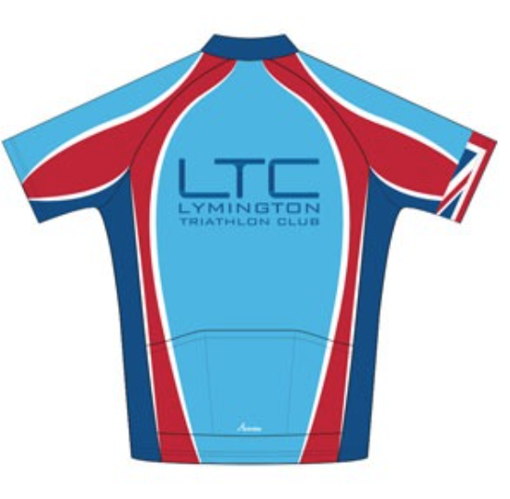
General Safety Guidance for LTC Cycling Club Rides
This document is provided by the LTC committee for individuals to conduct a ‘Self Risk Assessment’.
Completed by: Moz Malpiedi | Updated November 2024

Duty of Care
The LTC committee and Activity Captains have taken the responsibility of preparing this Safety Guidance Document to help keep all our club members and members of the public safe. Please be familiar with it and conduct your own risk assessment prior to taking part in any club activity.

All participants are reminded that they are responsible for their own safety, individuals take part in any group activities at their own risk.

Insurance
LTC is affiliated to British Triathlon and as such we have Public Liability insurance for club events, however, many activities are set up by members and are not formal club events so we strongly urge all participants to obtain appropriate 3rd party insurance as a minimum. It should be noted that no liability shall be attached to the LTC (including its officials and members) for any injury, loss or damage suffered. Club members are encouraged to join British Triathlon and get their personal public liability insurance via membership to British Triathlon. www.britishtriathlon.org/join/essential
Note: potential new members are only covered by LTC’s Public Liability Insurance for 3 taster sessions after that they need to join or not attend any further sessions.
Please read on and make yourself familiar with the contents of this document.
If you have any questions/comments/ideas do not hesitate to contact a member of the committee or a nominated club official.

Types of incidents that have happened over the past few years within the club whilst Cycling
- Colliding with a pothole.
- Colliding with a car.
- Near misses with overtaking cars
- Slipping on wet or icy surfaces.
- Falling on rough, off-road terrain
- Going into the back of another rider.
- Bonking (running out of energy).
- Heart problems

Pre-ride checks and general advice
Equipment: Breakdown, stranded | - It is suggested that each rider to carry minimum tool kit comprising of:  - Method of tyre inflation  - At least one spare inner tube (recommended two)  - Two/three tyre levers  - Multi­tool including Allen keys  - Chain splitter  - Mobile phone / money for phone
Equipment: Condition, accident | - Cycles must be legal and roadworthy.  - Riders to inspect their cycle prior to each ride paying particular attention to brakes, frame, steering, pedals / cleats, wheels and tyres.  - Riders to ensure your cycle is regularly serviced / maintained by a competent mechanic.
Equipment: Clothing – visibility, comfort and safety | - Riders to assess weather conditions and dress / prepare appropriately.  - Recommend high visibility clothing / jackets  - Riders to wear approved safety helmets – no helmet, no ride!  - Suggest the wearing of suitable eye protection.  - Mudguards are recommended during the winter months  - Carry mobile phone and ICE details (loading What3Words App is recommended  - Suggest wearing an ID bracelet
Equipment: Food / Drink | - Riders have responsibility for ensuring that they carry sufficient food / drink / energy gels for duration of ride  - Carry money to purchase food / drink.
Preparation: Health | - Riders to ensure they are aware of the distance / pace of the ride to be undertaken and are of a sufficient level of fitness to complete the ride  - Do not start any ride if you are feeling unwell or do not think you are able to complete it  - If during a ride you become unwell, inform the road captain or group leader immediately.
New riders | - Any guest / new rider must introduce themself to the Ride Leader  - New members should contact the club in advance (details on the website)  - Guest / new rider must be conversant with the contents of this document

Issue/potential hazard | Guidance | Additional comments
Communication | - Lead rider on the day will usually provide:  - A short overview of the route, any café stops, likely duration and distance.  - Any known route hazards, diversions, or other considerations  - Check of presence of new members or guests  - Reminder to stay in small groups | Anyone with any concerns should free to air them at any time.  Any new club members should identify themselves to the rest of the group and ride leader
Group Size / Rider Experience: accident, traffic problems | - Large groups of cyclists pose a hazard due to difficulty in overtaking by other road users, so it is important to split into smaller groups ideally less than 5 – leaving a suitable gap between each group.  - Be familiar with the Highway Code (Rules 59 to 82) and advice on where/when to ride two abreast or single file (Rule 66).  - Always follow any instruction given by the Road Captain or rider leader.  - Tri­bars must not be used in groups on club rides. | Experienced riders need to lead by example and advise other riders to comply with road safety guidance.
Collision / Accident: | - All riders to be conversant with group ride calls, hand signals and warnings and ensure that these calls are passed along the line.  - Ride smoothly and consistently, be aware of those around you and do not brake without warning  - Concentrate at all times and anticipate changing road conditions  - When negotiating unforeseen road conditions (such as potholes) riders should be aware that their actions impact on others  - Ride slightly behind and to one side of the wheel in front and with sufficient safe gap if not confident/competent to ride immediately behind the wheel in front.  - Do not let your front wheel overlap that of the rear wheel of the bike in front | Regularly issue guidance regarding cycling calls and warnings via club social media postings
Collision / Accident:  motor vehicle, other road users | - Riders must conform to the Road Traffic Act and always follow the advice of the Highway Code.  - Riders will obey all traffic signals and signs.  - At times of poor visibility, wear bright clothing and if necessary, use cycle lights.  - All riders to continually assess traffic conditions, driver attitudes and carry out dynamic risk assessments. e.g. get off and walk / use a pedestrian crossing if you have to cross a major road.  - Should the need to stop arise e.g. through puncture, breakdown etc. then a place must be found sufficiently off the road to allow safe passage of traffic.  - Consider using person(s) at strategic points to warn oncoming traffic of any obstruction.  - Riders to warn of approaching vehicles using known calls (“car back” “car up”) | All accidents to be reported as per the Road Traffic Act and to the Committee. An accident report submitted detailing the circumstance  Report all near misses so they can be shared before club rides
General guidance for safe bike riding
Issue | Advice | Further comments
Medical incident  Dehydration, Heat stroke, Hyperthermia, Fibrillation | - Each rider needs to self-assess if they are fit enough to join a club ride and inform the cycling captain (or buddy) of any limitations.  - Riders need to carry their own medication and inform others if their assistance may be required i.e. EpiPen or Insulin  - Each rider to ensure they have enough water in their bidon. If anyone runs out, they should ask a fellow rider or arrange for a stop to fill up.  - No one should feel embarrassed to stop and ask for help if they feel unwell | It is recommended that all riders have the following apps on their mobile phones:  - First Aid (what to do…)  - What3Words (for location)
Accident:  Falling off the bike | - Always pay close attention to the road surface in front of you, being alert for potholes, broken tarmac sections, raised covers, cattle grids, and stray objects.  - Please Note: accidents associated potholes have been the biggest source of serious injuries on our rides – PLEASE BEWARE  - Dynamically risk assess any changes identified, e.g., consider dismounting to cross a ford.  - Be aware of the calls / warnings in relation to changes in surface such as potholes and use / pay attention to these warnings.  - Note, when going downhill the lead rider may be unable to point out hazards (due to speed and or bumps on the road) so each rider should maintain a good view of the road ahead is important.  - Greater vigilance is required when following a rider, riding into the sun or in poor visibility.  - Only ride at a speed at which you are competent / confident particularly on descents. If you are leading a group, try to look ahead as much as possible to provide early warning.  - Ice on the roads should be brought to the attention of the group immediately  - Beware during windy conditions, cross winds from breaks in hedges/buildings can cause sudden, involuntary, movements of the bike | Familiarity with and frequent use of recognised hand signals and audible warnings for road hazards ahead. Lead riders to signal where practicable.  Consideration will be given to cancelling club ride if the roads are icy or prevalence of high winds.  Should a club ride set off and there be a risk of ice then there should be a continual dynamic risk assessment of the conditions. Consideration should be given to;  a) Whether to call ride off  b) Changing the route  c) Sticking to main roads if they are clear of ice.
Stopping | - Always choose a safe place to stop as a group, and avoid road junctions, bends and other physical road hazards.  - Warn riders before stopping and keep the carriageway clear.  - In the event of punctures, breakdowns etc. clear the carriageway if possible, or group leader to instruct the group to continue to a safe waiting place.  - Assess the problem and decide whether to hold up the ride or leave the affected rider with helpers and details of the route to the next stop(s).  - If unsure of the route, stop well before junction to consult map. Check for presence of back marker at junctions. If necessary, wait for slower riders beyond the junction.
Passing horses and animals | - On approach to a ridden horse, the lead rider should warn the horse and horse rider by verbal communication that a cyclist present and behind. Thereafter proceed and pass by slowly.  - Heed any advice given by horse rider. (Horses can be spooked by bikes it is essential that the horse hears the human voice before it sees the bike.  - Beware of New Forest ponies, pigs and deer – all can act in an unpredictable manner | Use of a bell is strongly recommended

Supporting attachments:
- Cycling Hand Signals
- Highway code for cyclists

Cycling Hand Signals
Stay safe when group cycling on the roads by using these five important hand signals, kindly provided by British Cycling. Note, audible warnings are also important.

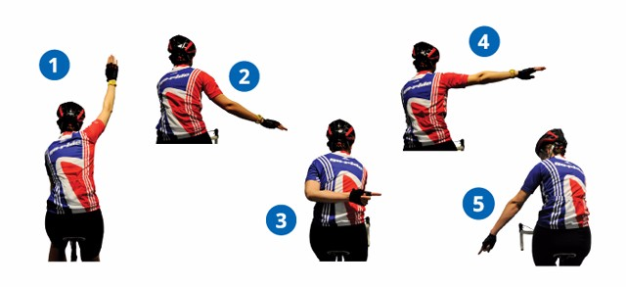

1 STOP
Hand straight up in air and shout STOPPING. Group is stopping for a junction, puncture or because there is an obstruction in the road.

2 SLOW
Shout SLOWING and move one hand as if gently patting an invisible dog. Group is slowing down or just easing things back a bit.

3 OBSTRUCTION
Waving/pointing behind back indicates that there is an obstruction such as a parked car or pedestrian and that the whole group needs to move in the direction indicated to avoid it.

4 TURN
Left or right hand extended out to side. Direction of turn/change in direction coming up.

5 BELOW
Pointing down at road sometimes with a circling motion to obstruction on road such as a pothole or drain cover that needs to be avoided. Be sensible with this one and only point out major obstacles. This signal is often accompanied with a call of “HOLE or BELOW”.

6. TRAFFIC
Shout CAR UP or CAR BACK to warn of oncoming or overtaking cars

THE HIGHWAY CODE (Revison sept 2023) RULES (59 TO 82) FOR CYCLISTS

You can find a full version of the Highway Code here: https://www.gov.uk/guidance/the-highway-codeR
You should:
- Never ride more than two abreast, and ride in single file on narrow or busy roads and when riding round bends
- Not ride close behind another vehicle
- Be considerate of other road users
- Look well ahead for obstructions in the road, so that you do not have to swerve suddenly to avoid them
- Take care when overtaking
You MUST NOT:
- Ride in a dangerous, careless or inconsiderate manner
You MUST obey all traffic signs and traffic light signals
Before overtaking you should make sure:
- The road is sufficiently clear ahead
- Road users are not beginning to overtake you
- There is a suitable gap in front of the road user you plan to overtake.
Road positioning.
When riding on the roads, there are two basic road positions you should adopt, depending on the situation.
1) Ride in the centre of your lane, to make yourself as clearly visible as possible, in the following situations
- on quiet roads or streets – if a faster vehicle comes up behind you, move to the left to enable them to overtake, if you can do so safely
- in slower-moving traffic - when the traffic around you starts to flow more freely, move over to the left if you can do so safely so that faster vehicles behind you can overtake.
- at the approach to junctions or road narrowings where it would be unsafe for drivers to overtake you
2) When riding on busy roads, with vehicles moving faster than you, allow them to overtake where it is safe to do so whilst keeping at least 0.5 metres away, and further where it is safer, from the kerb edge. Remember that traffic on most dual carriageways moves quickly. Take extra care crossing slip roads.
Animals. When passing animals, go by slowly. Give them plenty of room and be ready to stop.
Horse riders and horse-drawn vehicles. Be particularly careful of horse riders and horse-drawn vehicles especially when overtaking. Always wait until it is safe to do so and pass wide and slowly on their outside after calling out or ringing your bell. Look out for horse riders’ and horse drivers’ signals and heed a request to slow down or stop. Take great care and treat all horses as a potential hazard; they can be unpredictable, despite the efforts of their rider/driver.
Double white lines where the line nearest you is solid. This means you MUST NOT cross or straddle it unless it is safe and you need to enter adjoining premises or a side road. You may cross the line if necessary, provided the road is clear, to pass a stationary vehicle, or overtake a pedal cycle, horse or road maintenance vehicle, if they are travelling at 10 mph (16 km/h) or less.

