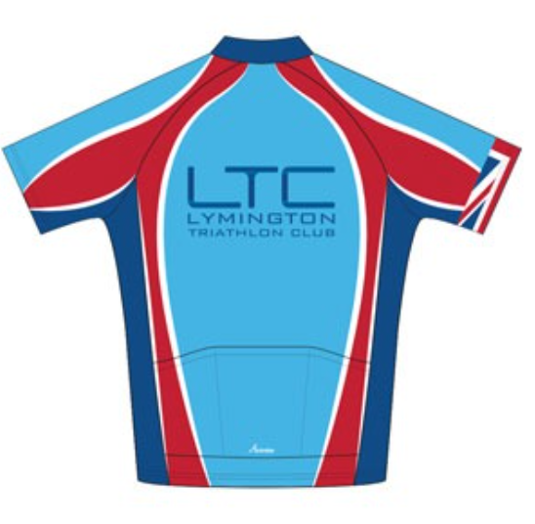


General Safety Guidance for LTC Runs in the New Forest – November 2024
This document is provided by the LTC committee for individuals to conduct a ‘Self Risk Assessment’.
Risk Assessment: Forest Runs | Location: New Forest or around Lymington
Completed by: Robert Norley | Updated November 2024

Duty of Care
The LTC committee and Activity Captains have taken the responsibility of preparing this Safety Guidance Document to help keep all our club members and members of the public safe. Please be familiar with it and conduct your own risk assessment prior to taking part in any club activity.

All participants are reminded that they are responsible for their own safety, individuals take part in any group activities at their own risk.

Insurance
LTC is affiliated to British Triathlon and as such we have Public Liability insurance for club events; however, many activities are set up by members and are not formal club events so we strongly urge all participants to obtain appropriate 3rd party insurance as a minimum. It should be noted that no liability shall be attached to the LTC (including its officials and members) for any injury, loss or damage suffered. Club members are encouraged to join British Triathlon and get their personal public liability insurance via membership to British Triathlon. www.britishtriathlon.org/join/essential
Note: potential new members are only covered by LTC’s Public Liability Insurance for 3 taster sessions after that they need to join or not attend any further sessions.
Please read on and make yourself familiar with the contents of this document.
If you have any questions/comments/ideas do not hesitate to contact a member of the committee or a nominated club official.
Types of incidents that have happened over the past few years within the club whilst running.

- Slips and trips.
- Bumped heads.
- Cramps.
- Heart problems.
- Heat exhaustion

Hazard | Possible outcome / injury
Hazard | Notes on potential severity | Likelihood | What control measure?
- Uneven surfaces  - Slippery surfaces  - Tree roots/branches  - Uneven slabs, kerbstones | - Tripping / slipping – minor injury  - Impact with low branches - minor to major injury | MEDIUM | Course appropriate to those taking part.
 |  | MEDIUM | Suitable footwear to be worn by participants, and care taken when wearing peaked caps.  Warning shouts for any low branches, potholes, etc.
- Slopes/steps | Falls – minor, or possibly major, injury | MEDIUM | Course appropriate to those taking part.
- Slopes/steps | Falls – minor, or possibly major, injury | MEDIUM | Course hazards to be pointed out en route
- Poor lighting/dark (particularly during the winter months) | Colliding with something or tripping - minor to major injury | MEDIUM | Chose an appropriate course.  Wear a suitable head-torch  Wear bright, reflective clothing  Run slower  Shout out warning about trip hazards/obstructions
- Vegetation (prickly, stinging) | Scratches or stings – trivial injury | MEDIUM | Suitable leg and torso cover to be worn.
- Wire / ruined fences | Scratches – minor injury | LOW | Fence climbing to be avoided
- Litter (glass, used needles) | - Glass cut – minor injury  - Needle-borne infection – major injury | NONE
- Water (water courses, marshes, ponds) | Drowning – serious injury or death | LOW | Identified by run planner in advance, or dynamically on run. Routes planned to avoid them
- High walls, unguarded steep edges | Falling – serious injury or death | LOW | Identified by run planner in advance, or dynamically on run. Routes planned to avoid them
- Traffic (including road crossings) | Collision between runner and vehicle – serious injury or death | LOW | Road crossing to be avoided where practicable. Where road needs to be crossed, group to cross as a whole, when safe to do so.  Road running to be minimised, but where it takes place, run at side of road, single file & facing oncoming traffic.
- Railway lines | - Collision between runner and train – serious injury or death  - Contact with electrified lines - serious injury or death | LOW | Identified by run planner in advance, or dynamically on run. Planned routes will avoid busy lines such such as the Southampton/Bournemouth line and use rail bridges and under-passes.  Only designated crossing points on the Lymington/Brockhurst line will be used (clear line of sight/good signage/ good gates) – with care!
- Wildlife & livestock | Kicks / bites from wild / roaming animals & livestock if disturbed / frightened | LOW | Group to give animals given a wide berth. Participants used to running in the New forest and aware.
* Tick bites | Potential of contracting Lyme Disease, and other tick-borne diseases - mild to serious chronic illness | MEDIUM | Leg check at end of run. Consider wearing running longs in times of high tick activity. Participant to seek medical advice immediately on developing a rash from a tick bite.
- Clothing / shoes | Poor temperature control – see ‘Heat’ and ‘Cold’  Slipping or twisting ankle – minor injury | LOW | Clothing suitable for walking/running in woods and open moorland.
- Existing medical conditions  - Unexpected reactions/allergies | Sudden serious illness or death | LOW | Participant to decide whether they are fit enough for proposed run. Participant to alert Run Leader of any underlying serious health concern pertinent to run.
- Lost participant | Unable to locate self or find way back to group. | LOW | Run Leader to ensure that participants run as a group, that the pace is appropriate and that group waits/runs back for any straggler. Run Leader to designate experienced buddy for any participant struggling.
- Disorientation (inclucing caused by tiredness) | - Longer exposure to heat/cold than planned for – usually minor (see ‘Heat’ and ‘Cold’ for major considerations)  - Lost – stumble across hazard away from courses resulting in injury - usually minor (see individual hazards for major considerations)  - Lost – unable to find way back | LOW  LOW | Courses appropriate to those taking part. Course route pre-planned or tailored dynamically to suit group.
- Disorientation (inclucing caused by tiredness) |  | LOW  LOW | Group running to reduce likelihood of individuals straying off-course
- General public  - Cyclists  - Horse riders  - Vehicles | - Runner collides with walker - minor injury  - Collision with cyclist – minor injury  - Collision with horse – minor - major injury  - Collision with vehicle - minor to major injury | LOW  LOW  LOW  LOW | Participants advised to take care when encountering other activities, and in the rendezvous car-park.
- Dogs being walked | Attacked by uncontrolled dog – minor to major injury | LOW | Participants advised to take care near dogs.
- Wildlife & livestock | - Kicks / bites from wild animals and livestock (pigs, cattle, ponies, and donkeys if disturbed/frightened)  - Tick borne Lyme Disease  - Viper bite | LOW | Alert participants to avoid livestock and wild animals.  Alert participants to risk of tick bites, carry out tick check after run, advise seek urgent medical help if bitten and rash develops.  Vipers normally hibernate in winter, but can be active all seasons - seek urgent medical help if bitten.
- Forest maintenance | Machinery/ Falling tree/Log piles – major injury | LOW | Areas being worked are signed by Forestry England. Run Leader ensures courses planned to avoid.
- Pheasant shoots | Accidental shooting – serious injury or death | NONE | Avoid running on land in proximity of an active shoot.
- Stranger danger | Vulnerable person injured by stranger | LOW | Under-18’s to be chaperoned by responsible adult. Group running to avoid lone participants.
- Heat / sun | Heatstroke – serious injury or death | LOW | Course duration limited to say 90 minutes in hot conditions. Courses in mixed forest (shaded) and heathland. Appropriate running clothing to be worn by participant. Regular water stops.
- Cold / rain / snow / hail / ice | - Hypothermia – serious injury or death  - Slippery surfaces – major injury | LOW  MEDIUM | Participant to wear appropriate clothing & footwear Plan for event cancellation if necessary, dependent on weather conditions.  Curtail course if necessary.
- High winds  - Lightning | - Wind blown items / falling branches – major injury  - Lightning strike – major injury | MEDIUM | Choose course appropriate for weather. Curtail course if necessary. Plan for event cancellation if necessary.

