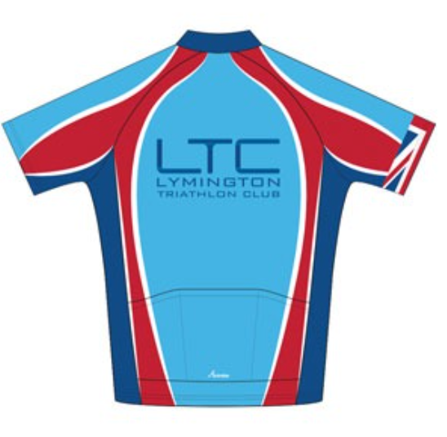

General Safety Guidance for LTC Open Water (Sea) Swimming Sessions
This document is provided by the LTC committee for individuals to conduct a ‘Self Risk Assessment’.
Completed by: Moz Malpiedi | Updated November 2024

Duty of Care
The LTC committee and Activity Captains have taken the responsibility of preparing this Safety Guidance Document to help keep all our club members and members of the public safe. Please be familiar with it and conduct your own risk assessment prior to taking part in any club activity.

All participants are reminded that they are responsible for their own safety, individuals take part in any group activities at their own risk.

Insurance
LTC is affiliated to British Triathlon and as such we have Public Liability insurance for club events; however, many activities are set up by members and are not formal club events so we strongly urge all participants to obtain appropriate 3rd party insurance as a minimum. It should be noted that no liability shall be attached to the LTC (including its officials and members) for any injury, loss or damage suffered. Club members are encouraged to join British Triathlon and get their personal public liability insurance via membership to British Triathlon. www.britishtriathlon.org/join/essential
Note: potential new members are only covered by LTC’s Public Liability Insurance for 3 taster sessions after that they need to join or not attend any further sessions.
Please read on and make yourself familiar with the contents of this document.
If you have any questions/comments/ideas do not hesitate to contact a member of the committee or a nominated club official.

Types of incidents that have happened over the past few years within the club whilst Open Water Swimming
- Panic attacks.
- Cold and shivering.
- Swimming out of sight and ‘lost for a short time’.
- Cramps.
- Bruising after being rolled by a large wave.
- Close encounters with a seal.
- Heart problems.
- Cuts and scrapes going over groynes or hitting submerged rocks

Location | Lymington, MoS, Avon etc | Activity | Weekly LTC social swim meets (typically Sunday mornings)  But, this guidance applies to solo/ad hoc swims too
First Aid and Emergency Equipment | Whistle, First Aid kit, mobile phone, Warm blanket/clothing | Emergency Action Plan | Call Coast Guard or RNLI both are on 999 or 112
Pre-swim briefing | - Discuss tide direction.  - Agree who is going to which turning point.  - Agree on alert system/signal if someone has difficulty in the water.  - Ideally swimmers are ‘buddied up’.  Remind everyone that they need to be visible to be seen by other water users or in the event of difficulty

This self-risk assessment covers organised LTC swim meets, typically on Sundays.

Other swimming meets are usually arranged between individuals and are not club events.

Phase | Hazard | Level of Risk | Action by individuals taking part
Pre-entry | Bad weather | Low  These LTC swim meets are generally summer only activities | - Check Weather forecast and visual check of current conditions  - If weather deteriorates call the meet off particularly for lightening or high winds
 | Rough Sea | Medium | - Check weather forecast and visual check at the beach  - If the waves or swell get worse call off the meet.  - Avoid entry on wrong side of a groyne.
 | Swimmer poor health or feeling unwell | Low | - No swimming with open wounds or infection  - Self-assessment, if you don’t feel well don’t enter the water
 | Novice/poor swimmer – drowning, panic attack | Low | - All swimmers to ‘self-assess’ and confirm that they have strong pool swimming skills. If you don’t feel confident, try and ask someone to remain on land and spot for you.  - Wear wet suits for buoyancy and attach floats
 | Low water temperatures leading to gasp reflex, cold incapacitation, hyperthermia, panic attacks | May - November (Low)  December - April (Medium)  LTC meets are generally summer only activities | - Wear wet suits for buoyancy and attach floats if inexperienced  - Wear a swimming cap and googles  - Ear plugs can help to prevent nausea and disorientation/panic  - Swim with a buddy - watch out for signs of cold incapacitation in your buddy and yourself, and get out if struggling  - Enter cold water in stages to reduce gasp reflex  - Familiarise yourself with typical cold-water exposure times - particularly if not acclimatized to cold water swimming:  - Restrict to small time intervals below 11 C (1min for each degree below 10C, e.g. 5C = 5min max in water)  - 10 mins at 11 C  - 15 mins at 12 C  - 20 mins at 13 C  - 60 mins max at >13 C  Note these are just guidelines for beginners and everyone will have a difference tolerance to cold water  - See link: https://www.outdoorswimmingsociety.com/tips-on-winter-swimming/
 | Poor water quality | Low | - NFDC water quality tests at Milford-on-Sea are conducted annually (classified as Excellent)  - Use the SSRS (Safer Seas and Rivers service) app for water quality updates and warnings of sewage spills (Avon beach is regularly flagged up after rainfall)  - Environment Agency Water Quality MoS  - See a GP if you feel ill (fever and or diarrhea) within 48 hrs of swim and inform the club
Water entry/exit | Rough ground  Gasp reflex and water aspiration | Low | - Generally, a gentle slope into the sea  - Wear waterproof shoes if the stones feel uncomfortable on your feet  - Enter cold water in stages to acclimatize and reduce gasp reflex
In the water | Drowning, panic attacks, cramp | Medium | - All swimmers to ‘self-assess’ and novice swimmers to confirm that they have strong pool swimming skills (ideally a minimum 200m continuous swimming)  - We strongly recommend that all swimmers wear a wet suit for buoyancy and always attach floats for visibility/security plus attach a whistle and/or a flashing light to attract attention.  - Try to swim with a buddy if possible or notify someone where you will be.  - Swimmers to wave for assistance if in trouble  - All swimmers to keep an eye out for others in distress  - If you feel begin to feel anxious in the water change your stroke or float on your back until you can regulate your breathing
 | SIPE - Swimming Induced Pulmonary Edema | Low/Rare – but can occur in all temperatures | - SIPE: Swimming Induced Pulmonary Edema is a condition that causes severe, sudden breathlessness during open water swimming. It may include symptoms of coughing, phlegm, and tight chest. Some evidence to suggest that it is more associated with wearing a wet suit and longer swims in cold water.  - GET OUT OF THE WATER as quickly as you can.  - https://outdoorswimmer.com/featured/dont-panic-about-sipe/
 | Strong tide carrying you out | Medium | - Use a Tide App to determine direction of tide. If uncertain, stay close to the shore until you understand which way it is flowing  - The tides at MoS can be strong due to the large water flows in/out of the narrow channel between Hurst Spit and the IOW  - If in doubt swim with the tide and understand where you can get out if in trouble  - Note, the tides at Needle Eye or near Hurst castle can be difficult to read.
 | Collision of swimmers | Medium | - Brief on swim direction  - Be aware of non-club swimmers.  - Watch where you are going – sighting frequently!
 | Fishing lines | Medium | - Before setting off look for fishermen on the beach  - If you see fishermen with lines in the water when swimming, watch out for their lines, communicate with them to either bring their lines in or whether to go under or around  - Beware of getting entangled in discarded fishing lines and nets (some swimmers carry a small penknife in their float)
 | Collision with a craft | Low | - Look for potential kayakers, sail boarders in the water where you may be swimming  - Stay within a reasonable distance of the shore to avoid motorised craft  - Remember you need to BE VISIBLE to be seen by others
 | Jelly fish stings | Low | - Most stings from sea creatures in the UK are not serious and can be treated with first aid. Sometimes you may need to go to hospital. Advice from NHS:  - Rinse the affected area with seawater (not fresh water)  - Remove any spines from the skin using tweezers or the edge of a bank card.  - Soak the area in very warm water (as hot as can be tolerated) for at least 30 minutes – use hot flannels or towels if you cannot soak it.  - Take painkillers like paracetamol or ibuprofen.
 | Sammy the Seal gives you a nudge | Low | - Don’t annoy him and don’t eat his fish, he was there first!  - If you remain calm, quiet and assertive in the water you will have the best experiences and be least likely to frighten them. When frightened though they are more likely to flight than fight when given an escape route  - If your skin is broken by a seal, you are advised to seek medical advice and take a special form of antibiotics – see your GP.  - See link: Outdoor Swimming Society
 | Underwater obstacles | Medium | - Do not swim over groynes unless you know what you’re doing – high risk of cuts and bruises and damage to wetsuits.  - Avoid swimming near the large rocks (some extend out to sea at Needles Eye and may be just below the waterline)  - Be aware of rusted and sharp WWII sea defenses – if in doubt ask.
Post-swim, out of water | Afterdrop and hypothermia | May - November (Low)  December - April (Medium) | - Afterdrop normally occurs 10 minutes after leaving cold water  - Be aware of the “umbles” in others: grumble, fumble, mumble and stumble are signs of afterdrop and hypothermia.  - Dry and dress in warm clothing straight after leaving water - put yourself in a warm place.  - Consume hot drink/avoid cold drink initially  - Shivering will aid warming - don’t resist  - See link: https://www.outdoorswimmingsociety.com/tips-on-winter-swimming/

Action
Date Reviewed

