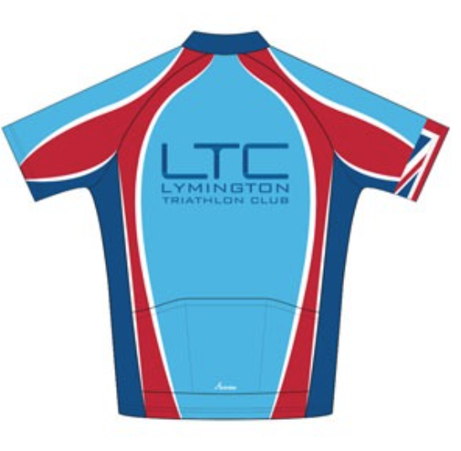
General Safety Guidance for LTC Coached Pool Swimming Sessions
This document is provided by the LTC committee for individuals to conduct a ‘Self Risk Assessment’.
Completed by: Moz Malpiedi | Updated November 2024

Duty of Care
The LTC committee and Activity Captains have taken the responsibility of preparing this Safety Guidance Document to help keep all our club members and members of the public safe. Please be familiar with it and conduct your own risk assessment prior to taking part in any club activity.

All participants are reminded that they are responsible for their own safety, individuals take part in any group activities at their own risk.

Insurance
LTC is affiliated to British Triathlon and as such we have Public Liability insurance for club events, however, many activities are set up by members and are not formal club events so we strongly urge all participants to obtain appropriate 3rd party insurance as a minimum. It should be noted that no liability shall be attached to the LTC (including its officials and members) for any injury, loss or damage suffered. Club members are encouraged to join British Triathlon and get their personal public liability insurance via membership to British Triathlon. www.britishtriathlon.org/join/essential
Note: potential new members are only covered by LTC’s Public Liability Insurance for 3 taster sessions after that they need to join or not attend any further sessions.
Please read on and make yourself familiar with the contents of this document.
If you have any questions/comments/ideas do not hesitate to contact a member of the committee or a nominated club official.

Types of incidents that have happened over the past few years within the club whilst in the pool
- Colliding with other swimmers.
- Slipping on wet floors
- Cramp

Phase
Hazard
Lev
HIGH, MED

Location | Lymington or New Milton Sports and Leisure Centres | Activity | Winter coached pool swim sessions.
First Aid and Emergency Equipment | The Lesure centre have first aid equipment. | Emergency Action Plan | Call life-guard  Call ambulance
Pre-swim briefing | Coach to brief swimmers on plan for the session.

This self risk assessment only covers organised LTC coached pool swim sessions which typically occur during the winter period.

All swimmers are expected to wear swimming costume and goggles. Swim caps are optional.

Phase | Hazard | Level of Risk | Action
Pre-entry | Swimmer poor health/Medical episode | Low | No swimming with medical condition that could negatively affect swimming.  No swimming with open wounds.  No swimming with infectious illnesses.  No swimming with known conditions that cause concern – consult GP.  Swimmers to be responsible for self-assessment  Call for assistance if feeling unwell.
 | Under 18s | Low | Only adults are permitted.
 | Novice/poor swimmer (panic attack/drowning) | Low | Only competent swimmers to be permitted.  All swimmers to self-assess their skills and discuss with coach
 | Poor water quality | Low | New Milton/Lymington Centre are responsible for ensuring water quality.  If there are concerns then centre manager to be called.  Pool session may need to be cancelled.  See a GP if you feel ill (fever or diarrhoea) within 48 hours of swim and inform club and centre.
Entry to pool | Slipping, falling. | Low | Members are reminded to walk carefully to the pool side.  Any accidents to be reported to the Centre manager.
In the water | Drowning, panic attacks, cramp | Low | Swimmers to call for help/wave their arms if they need help.  Life guard to attend to swimmer.  More confident swimmers assist if necessary.  Remain on the side of the pool or in shallow end until symptoms pass.
 | Collision of swimmers | Low / Medium | Swim in direction signposted/coach directs.  Swim in the lanes.  Be aware of less confident swimmers.  Be aware of faster swimmers and allow them to pass.  If touched on feet by swimmer behind wait at end of lane to allow them past.  Watch where you are going.
 | Diving | Low | Diving and jumping into pool not permitted with the exception of controlled coached diving sessions.
 | Exhaustion | Low | Duration limited to 60 minutes.  Rest if too tired or feeling unwell.
 | Dehydration | Low | Swimmers advised to bring water bottles.
Action
Date Reviewed

